Meeting Minutes

**Project:**

Entrepreneurship Support

Platform

**Meeting Type:**

Meeting with the Entrepreneurial Code Crafters

**Date:**

20 October 2024

**Time:**

12h00

**Location:**

Computer Room 2 (IIE Varsity College Durban North Campus)

**Meeting Facilitator:**

Lilitha Njeje

**Minutes Taker:**

Sibusisiwe Kunene

Call to order

•

Time: 10h00

•

Facilitator/

Chairman: Lilitha Njeje, she is our database administrator and also our group leader.

Attendees and Apologies

Malibongwe Ndlovu (Project Manager was present)

Lilitha Njeje (Database Administrator was present)

Sibusisiwe Kunene (Software Architect was present)

**Unavailable:**

Avarn Sewlal: (UI/UX Designer)

Hayley Chetty: (Technical Writer)

Allison Gopal: (Lead Developer)

.

Agenda

The meeting was held on the 20th of October at the IIE Varsity College Durban North Campus, Computer Room 2 alongside the Entrepreneurial Code Crafters.

The meeting was organized by our group leader, Lilitha Njeje, opened the meeting at exactly 10h00.

Detailed meeting notes

The meeting was set to discuss and update the changes we have made in our application.

We came to an agreement that we will remove the on-campus event for now and we also changed the group logo.

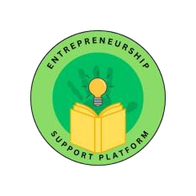

:

Adjournment

The meeting was closed at exactly 12:00.

Approval

**Minutes approved by:**

Sibusisiwe Kunene

20 October 2024 2024